Assignment 02 – Employee Attendance Monitoring System
Topics Covered
- Conditional Statements (if, elif, else)
- Loops (for, while)
- break
- continue
- pass

Business Scenario
You are working as a Junior Data Analyst in an organization.
The HR department wants a simple Attendance Monitoring System to classify employees based on their attendance percentage and generate a summary report.

Requirements
Part A – Attendance Classification
Accept attendance percentage for 10 employees.
Classify each employee using the following criteria:
Attendance % | Category
90 and above | Excellent
75 – 89 | Good
Below 75 | Improvement Required
Display the category for each employee.

Part B – Attendance Summary
Calculate and display:
- Total Employees Processed
- Number of Excellent Employees
- Number of Good Employees
- Number of Employees Requiring Improvement

Part C – Using break
Allow the user to stop data entry at any time.
If the attendance entered is:
-1
Stop processing further records using break.

Part D – Using continue
If attendance entered is:
0
Skip the current record and continue processing the next employee using continue.

Part E – Using pass
Create a placeholder block for future functionality.
Example:
if attendance > 100:
pass
Add a comment explaining what validation could be added in the future.

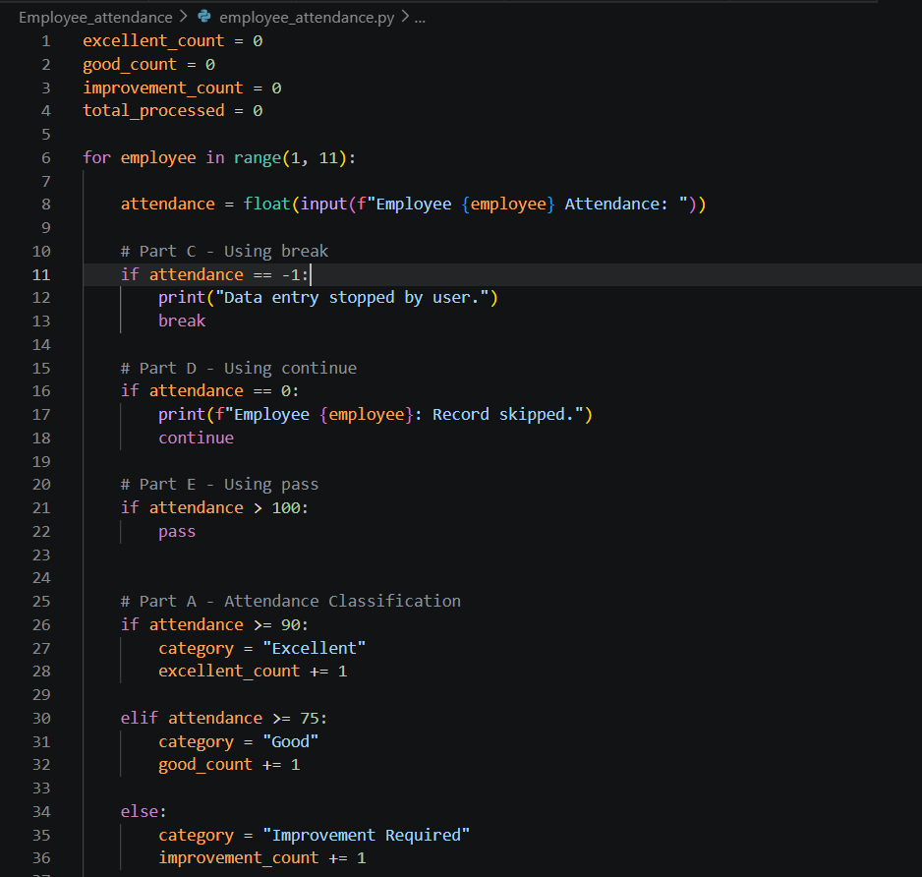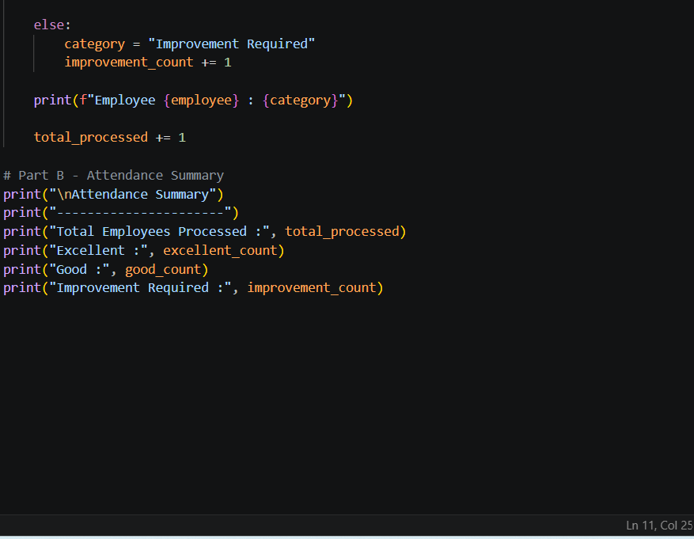

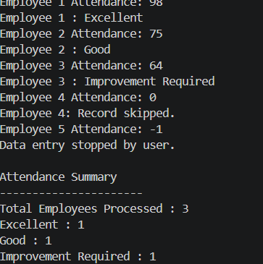

Sample Input
Employee 1 Attendance: 95
Employee 2 Attendance: 82
Employee 3 Attendance: 65
Employee 4 Attendance: 0
Employee 5 Attendance: 91
Employee 6 Attendance: -1

Sample Output
Employee 1 : Excellent
Employee 2 : Good
Employee 3 : Improvement Required

Attendance Summary

Total Employees Processed : 4
Excellent : 2
Good : 1
Improvement Required : 1

Deliverables
- Python Program
- Screenshot of Output
- README.md explaining the approach
- Upload to Personal GitHub Repository

Bonus Task
Generate additional insights:
- Highest Attendance Percentage
- Lowest Attendance Percentage
- Average Attendance Percentage
- Percentage of Employees in Each Category
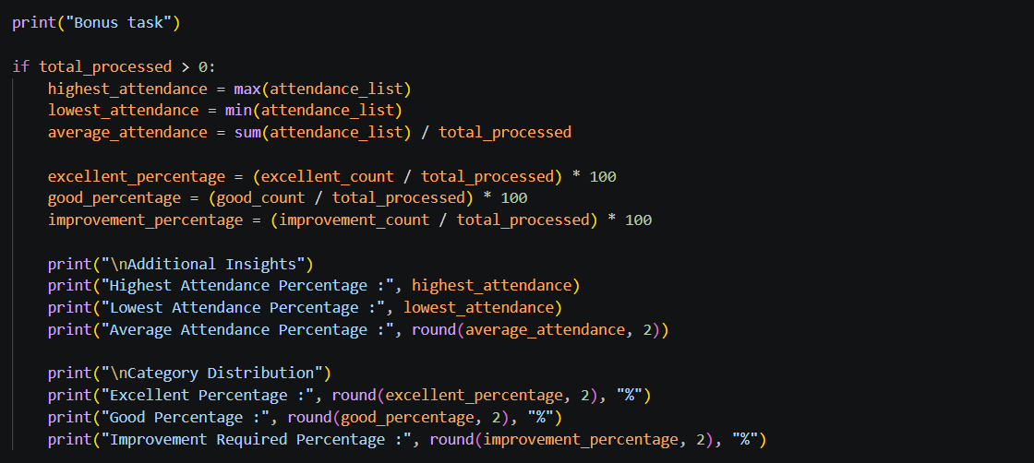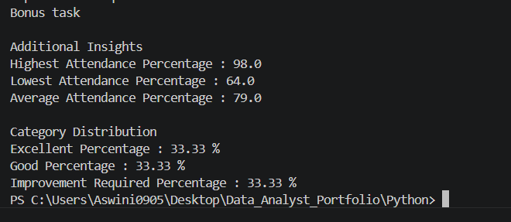

Learning Outcomes
After completing this assignment, you should be able to:
- Use if, elif, else for decision making
- Use for loops for repeated processing
- Use while loops for user-controlled execution
- Apply break to terminate loops
- Apply continue to skip iterations
- Understand the purpose of pass
- Build simple business logic using Python

